BLUE REPORT
Testosterone replacement therapy can be cautiously considered in this patient with Grade Group 3 prostate cancer after radical prostatectomy, given his favorable pathology (negative margins, no metastatic disease) and persistently undetectable PSA. While the Endocrine Society guideline states there is "inadequate evidence to quantify the risk-benefit ratio" and lacks a general recommendation, the American Urological Association and NCCN Survivorship guidelines acknowledge that TRT may be considered in selected prostate cancer survivors with no evidence of recurrent disease, coordinated with the oncology team.[1][2]

Oncologic Safety
The available evidence, though limited to retrospective studies, is reassuring. A 2025 systematic review found biochemical recurrence rates of 0-7% post-prostatectomy in TRT-exposed cohorts with up to 60 months of follow-up, with no studies showing increased recurrence risk compared to controls.[3] A large 2025 study from Memorial Sloan Kettering including 5,199 men (198 receiving TRT) with Grade Groups 1-3 found a nonsignificantly decreased risk of biochemical recurrence (HR 0.84, 95% CI 0.48-1.46) with TRT, and 5-year BCR probability <2% in both groups.[4] Multiple systematic reviews and meta-analyses consistently report no increased risk of biochemical recurrence with TRT after definitive treatment.[5][3][6][7]
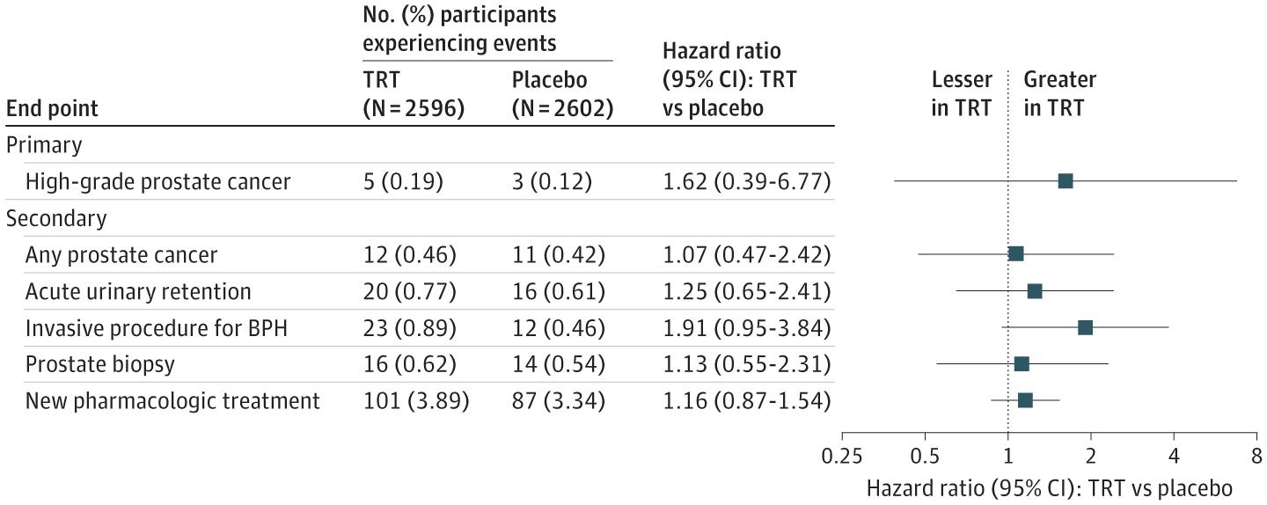Figure 2 Incidence of Primary (High-Grade Prostate Cancer) and Secondary Prostate Safety End Points.
Prostate Safety Events During Testosterone Replacement Therapy in Men With Hypogonadism: A Randomized Clinical Trial. JAMA Netw Open. November 30, 2023.
The following figure from the TRAVERSE trial demonstrates that testosterone treatment did not increase the risk of high-grade prostate cancer or other prostate safety endpoints in men with hypogonadism, though men at high risk for prostate cancer were excluded from this trial.
However, important caveats exist: all studies are retrospective with small sample sizes, short follow-up duration, and lack long-term survival data.[3][5] The Endocrine Society notes that existing trials are "underpowered and of too short duration" to detect effects attributable to testosterone therapy.[9] Additionally, TRT increases PSA levels, which may lead to increased biopsies and detection of subclinical cancers.[10]

Patient Selection Criteria
This patient represents a favorable candidate based on published selection criteria:[2][11][12]
- Organ-confined disease (no seminal vesicle invasion, negative lymph nodes)
- Negative surgical margins
- Undetectable PSA postoperatively (maintained for 12 months)
- Grade Group 3 (intermediate risk, not high-risk)
- Confirmed biochemical hypogonadism on two morning measurements
The AUA guideline specifically states TRT "can be considered in men who have undergone radical prostatectomy with favorable pathology (e.g., negative margins, negative seminal vesicles, negative lymph nodes), and who have undetectable PSA postoperatively."[2]

Expected Symptomatic Benefits
TRT consistently improves hypogonadal symptoms in prostate cancer survivors:[3][13]
- Sexual function: Improved libido, erectile function (though less effective if erectile dysfunction is the primary complaint)[10][14]
- Energy and fatigue: Significant improvements reported across studies[13]
- Mood: Decreased depressive symptoms[10][13]
- Anemia correction: In 42.9% of anemic patients in one cohort[13]
- Metabolic effects: Potential improvements in body composition, though data are mixed[13]
Testosterone levels typically increase from hypogonadal range (<300 ng/dL) to mid-normal range (300-500 ng/dL) with treatment.[4][13]

Monitoring Protocol
If TRT is initiated, rigorous surveillance is essential:[2][5][12]
Baseline assessment:
- Confirm hypogonadism with repeat morning total and free testosterone, LH, prolactin
- Document undetectable PSA
- Digital rectal examination
Ongoing monitoring:
- PSA every 3-6 months initially, then every 6-12 months[2][15]
- Testosterone levels to ensure therapeutic range
- Hematocrit (risk of polycythemia)
- Clinical assessment for lower urinary tract symptoms
Thresholds for concern:
- PSA ≥0.2 ng/mL with confirmatory rise (biochemical recurrence definition)[4]
- Rapid PSA velocity
- Abnormal digital rectal examination

Shared Decision-Making Discussion
The decision requires informed consent addressing:[1][9][2]
- Limited evidence: No randomized controlled trials; all data from retrospective studies with short follow-up
- Potential risks: Possible stimulation of occult disease, increased PSA leading to additional testing/biopsies, general TRT risks (polycythemia, cardiovascular events including pulmonary embolism)[10]
- Uncertain long-term safety: Lack of survival outcome data
- Need for intensive monitoring: Lifelong PSA surveillance required
- Coordination with oncology team: NCCN recommends coordination with surgeon/oncologist[1]
The NCCN Survivorship guidelines note that "when to initiate treatment for low testosterone in prostate cancer survivors...is controversial and should be coordinated with the patient's PCP (ie, surgeon, oncologist, radiation oncologist)."[1]

Recommendation
Given this patient's favorable pathology, persistently undetectable PSA, confirmed hypogonadism, and significant symptoms affecting quality of life, TRT may be cautiously offered with the understanding that this represents an individualized decision based on limited evidence. The patient should be counseled that while retrospective data are reassuring, definitive safety data from prospective trials are lacking. If he chooses to proceed, establish a rigorous PSA monitoring protocol and maintain close coordination with his urologic oncologist.
Would you like me to outline specific TRT formulation options and dosing strategies for this patient, or discuss how to counsel him if PSA becomes detectable during treatment?

References
- Survivorship. National Comprehensive Cancer Network. Updated 2026-02-02.
- Evaluation and Management of Testosterone Deficiency: AUA Guideline. Mulhall JP, Trost LW, Brannigan RE, et al. The Journal of Urology. 2018;200(2):423-432. doi:10.1016/j.juro.2018.03.115.
- Testosterone Replacement Therapy Following Definitive Treatment for Prostate Cancer: A Scoping Review of Safety and Efficacy. Gibson J, George M, Grice P, et al. International Journal of Impotence Research. 2025;:10.1038/s41443-025-01206-3. doi:10.1038/s41443-025-01206-3.
- Testosterone Therapy in Men After Radical Prostatectomy for Low-Intermediate Organ-Confined Prostate Cancer. Flores JM, Vertosick EA, Salter CA, et al. The Journal of Urology. 2025;213(1):27-33. doi:10.1097/JU.0000000000004267.
- Oncological Safety of Testosterone Replacement Therapy in Men With Localised Prostate Cancer: A Systematic Review of Observational Studies. Santucci J, Stapleton P, Perera M, et al. BJU International. 2025;. doi:10.1111/bju.16870.
- Oncological Safety of Testosterone Replacement Therapy in Prostate Cancer Survivors After Definitive Local Therapy: A Systematic Literature Review and Meta-Analysis. Kardoust Parizi M, Abufaraj M, Fajkovic H, et al. Urologic Oncology. 2019;37(10):637-646. doi:10.1016/j.urolonc.2019.06.007.
- Testosterone Therapy Does Not Increase the Risks of Prostate Cancer Recurrence or Death After Definitive Treatment for Localized Disease. Sarkar RR, Patel SH, Parsons JK, et al. Prostate Cancer and Prostatic Diseases. 2020;23(4):689-695. doi:10.1038/s41391-020-0241-3.
- Prostate Safety Events During Testosterone Replacement Therapy in Men With Hypogonadism: A Randomized Clinical Trial. Bhasin S, Travison TG, Pencina KM, et al. JAMA Network Open. 2023;6(12):e2348692. doi:10.1001/jamanetworkopen.2023.48692.
- Testosterone Therapy in Men With Hypogonadism: An Endocrine Society Clinical Practice Guideline. Bhasin S, Brito JP, Cunningham GR, et al. The Journal of Clinical Endocrinology and Metabolism. 2018;103(5):1715-1744. doi:10.1210/jc.2018-00229.
- Testosterone Treatment in Middle-Aged and Older Men with Hypogonadism. Bhasin S, Snyder PJ. The New England Journal of Medicine. 2025;393(6):581-591. doi:10.1056/NEJMra2404637.
- Testosterone Therapy in Men With Prostate Cancer. Kaplan AL, Hu JC, Morgentaler A, et al. European Urology. 2016;69(5):894-903. doi:10.1016/j.eururo.2015.12.005.
- Testosterone Therapy in Men With Prostate Cancer: Literature Review, Clinical Experience, and Recommendations. Morgentaler A, Conners WP. Asian Journal of Andrology. 2015 Mar-Apr;17(2):206-11. doi:10.4103/1008-682X.148067.
- Testosterone Replacement Therapy in Prostate Cancer Survivors Treated With Radiation With and Without Androgen Deprivation Therapy: A Retrospective Study and Narrative Review. Chandra MS, Wang C, Gagliano-Jucá T, et al. Endocrine Practice : Official Journal of the American College of Endocrinology and the American Association of Clinical Endocrinologists. 2026;:S1530-891X(26)00036-4. doi:10.1016/j.eprac.2026.01.019.
- Oncological Safety and Functional Outcomes of Testosterone Replacement Therapy in Symptomatic Adult-Onset Hypogonadal Prostate Cancer Patients Following Robot-Assisted Radical Prostatectomy. Shahine H, Zanaty M, Zakaria AS, et al. World Journal of Urology. 2021;39(9):3223-3229. doi:10.1007/s00345-020-03475-7.
- Testosterone Replacement Therapy in Patients With Prostate Cancer After Radical Prostatectomy. Pastuszak AW, Pearlman AM, Lai WS, et al. The Journal of Urology. 2013;190(2):639-44. doi:10.1016/j.juro.2013.02.002.

